Supplemental Materials for

##### A Course-Based Undergraduate Research Experience on the Evolution of Antibiotic Resistance and its Molecular Basis

Katie Dickinson1, Joya Mukerji1, 2, Stuart Graham1, Liz Warfield1, Ben Kerr1

1Department of Biology, Box 355320, University of Washington, Seattle WA 98195

2Present affiliation: Department of Biological Sciences, 6000 J Street, California State University – Sacramento, Sacramento CA 95819

**#Placeholder Table of Contents (Total pages 340)**



Part I.

Appendix 1: Student Lab Manual

Appendix 2: Student In-Class Worksheets

Part II.

Appendix 3: Instructor Lab Manual

Appendix 4: Prelab Quizzes

Appendix 5: Sample Clicker and Exam Questions

Appendix 6: Table of Learning Objectives: Vision and Change

Part III.

Appendix 7: Lab recipes and preparations

# to be removed/replaced upon submission

Table of Contents

APPENDIX 7: Lab Preparations and Recipes 4

Safety: 4

Summary: 5

Lab preparations summary table 8

Lab 1 9

Lab 1 Checklist: 9

Prep Steps 9

Experiment Prep 12

Lab 2 18

Lab 2 Checklist: 18

Prep Steps 19

Daily Transfers 22

Freezing down the progenitors 23

Lab 3 24

Lab 3 Checklist: 24

Lab 4 24

Lab 4 Checklist: 24

Lab 5 25

Lab 5 Checklist: 25

Prep Steps 25

T=1 Drop-In, competition plating 32

Lab 6 32

Lab 7 32

Lab 8 33

Lab 8 Checklist: 33

Prep Steps 33

Lab 9 38

Lab 10 38

Lab 11 39

Lab 12 39

Recipes 39

LB Broth 39

LB Agar Plates 40

LB Petri dishes with Antibiotics 41

Streptomycin Solution 42

Rifampicin Solution 43

Saline 45

Xgal/IPTG Agar Plates 46

Filter Sterilization 48

OPTIONAL: 49

Glossary 49

# APPENDIX 7: Lab Preparations and Recipes

## Safety:

We will be working with a non-pathogenic laboratory strain of *Escherichia Coli*. Prior to starting preparations for lab, you must complete all of your institution’s laboratory safety requires for working with a BLS-1 organism, autoclave, chemicals, etc. You must wear appropriate personal protection equipment (PPE) such as gloves and closed toed shoes whenever working with *E.coli*. Biohazardous waste must be disposed of properly. DO NOT eat, drink, chew a gum in the lab.

Autoclave:

An autoclave utilizes steam, heat and pressure to sterilize.

* Always use proper PPE (such as heat resistant gloves, eye protection and a lab coat) particularly when unloading the autoclave.
* Never autoclave items containing solvents, volatile or corrosive chemicals.
* Always use a, autoclave safe secondary container to contain spills.
* Never place sealed containers in an autoclave— due to pressure they might explode, keep caps on bottles loose.

Modify sterilization times as needed: timing will depend on a variety of factors such as volume, time of containers, microbial load, etc.

# Summary:

In this CURE, students first focused on evolution and ecology to explore evolution of antibiotic resistance by exposing *Escherichia coli* to specific drug regimes and assessing drug resistant levels, competitive fitness of isolates, as well as cross-drug resistance and sensitivity. In Part two, students trace genotype to phenotype at the cellular level, and connect evolution to molecular biology. These labs were piloted at a university which runs on the quarter system. Students enrolled in these classes met for lab once a week.

MG1655 is our focal strain *E.coli* strain. The common competitor strain is *E.coli* strain BW25113. The main difference between the two strains is deletion of araBAD and rhaDAB and the replacement of a section of lacZ in BW25133. As result BW25133 is: arabinose, rhamnose, lactose non-utilizing.

Of the 12 lab that make up this CURE, 4 labs require heavier preparations. Those labs are:

* Lab 1, Lab 2, Lab 5, and Lab 8.
* Lab 3, 4, and 6 have very minimal preparation steps needed.
* Lab 7, 9, 10, 11, and 12 require no “wet” lab work.

CURE prep needs overview

**Pre-quarter start**:

* Media:
  + LB broth
  + Saline
  + Petri dishes with and without antibiotics
* Autoclave loads:
  + To sterilize: pipette tips, glass beads, etc.
* Filling:
  + Non-sterile Eppi tubes: filled with water (for practices)
  + Sterile eppi tubes: filled with sterile saline and LB (for daily bacteria transfers),
  + Non-sterile microtiter plates (for sterile practice, lab 1 and transfer practice, lab 2)
* Labeling:
  + microtiter plates
  + eppi tubes
  + Petri dishes
* Beading Petri dishes
* Set-up lab
  + Gloves
  + Biosafety bins
  + Supply stations
  + Computers
  + Etc.
* Set-up student lab benches
  + Tip waste container
  + Non-tip waste container
  + Test tube racks holding P20 and P200 pipettes,
  + Sharpies
  + Eppi tube racks
  + Pipette tips
  + 70% ethanol bottle
  + Kim wipes



**Mid-quarter**\*:

(*Could potentially be pre-quarter but be careful how long you store items since antibiotics and the xgal/IPTG plates, are light and temperature sensitive)

* MIC microtiter plates (LB + antibiotics (multiple concentrations)
* Petri dishes + xgal and IPTG
* Restart bacteria strains and do the final bacteria transfer for the students
* Wash eppi tubes and microtiter plates to reuse
* Make gels
* Clean PCR produces to send away for sequencing

**Ongoing**:

* Lab set up
  + Weekly:
    - restock gloves, ethanol
    - white board images
    - restock tubes of LB and saline for bacteria transfers (starting mid-week lab 2 and continuing through lab 3 & 4), daily Tuesday – Thursday
    - Move items (petri dishes, microtiter plates, eppis) to lab from incubators and fridge and back again
* Autoclave loads:
  + Weekly: sterile pipette tips and do waste loads

**Post Lab**:

* tear down labs & put items away
* inventory
* organize, label and store petri dishes
* autoclave loads: waste

## Lab preparations summary table

The “busy” weeks for lab preparations are highlighted in yellow below.

|  |  |  |  |  |
| --- | --- | --- | --- | --- |
| Lab 1 | Lab 2 | Lab 3 | Lab 4 | Lab 5 |
| ***Experiment***   * MT plate with E.coli * Petri dishes, beaded: * LB * LB + RIF * LB + STR | ***Experiment***   * Student petri dishes from Wk1 * Empty, sterile MT plate * Eppi, LB * Eppi, Saline * Freeze strains | ***Experiment***   * Student MT plate with bacteria * Eppi, LB * Eppi, Saline | ***Experiment***   * Student MT plate with bacteria * Eppi, LB * Eppi, Saline | ***Experiment***   * Student’s MT prepped with descendants + ancestors + CC + LB + saline * MIC MT plates, RIF gradient * MIC MT plates, STR gradient * Eppis, saline * T=24 dilution plate with saline * Petri dishes with xgal & IPTG, beaded |
| **Other**   * MT with blue water * Eppi, water * Eppi, yellow water | **Other**   * MT with cloudy water * Eppi, water * Eppi, light yellow water | **Other**   * Computers with R & RStudio * R code * Practice data set | **Other**   * Computers with R & RStudio * R code * Practice data set |  |

|  |  |  |  |  |  |  |
| --- | --- | --- | --- | --- | --- | --- |
| Lab 6 | Lab 7 | Lab 8 | Lab 9 | Lab 10 | Lab 11 | Lab 12 |
| ***Experiment***   * Petri Dishes with colonies * MIC MT plates | ***Experiment*** | ***Experiment***   * Petri dishes with colonies from RIF.r and RIFr.d * Master Mix in PCR tubes * Dye * Gel | ***Experiment*** | ***Experiment*** | ***Experiment*** | ***Experiment*** |
| **Other**   * Computers * Clickers * Goggles | **Other**   * Computers with R & R studio * R code | * Preprogramed thermocycler * Illuminator * Ice | **Other**   * Computers   - Benchling  - Sequencing Data | **Other**   * Computers   - Benchling  - Pymol | **Other**   * Computers | **Other**   * Poster printer or projectors |

**Note: Most supplies for weeks 1-4 can be prepared ahead of time and stored (except the bacteria culture)

# 

# Lab 1

### Lab 1 Checklist:

**Make Media:**

LB broth

Saline

RIF stock solution

STREP stock solution

LB Agar

**Pour Petri dishes:**

LB Petri dishes

LB Petri dishes + RIF

LB Petri dishes + STR

**Prep items for a dry load:**

Restock tips

Add autoclave tape to pipette tip boxes

Add eppis to autoclave safe containers, cover with foil, add autoclave tape

Fill test tubes with clean glass beads (to bead Petri dishes)

**Run Dry Load:**

Pipette tips, eppis, glass beads, small bottle for antibiotic stocks

**Prep for sterile practice:**

Fill first column of microtiter plates with blue colored water

Label eppis

Fill eppis with clear water

Fill eppis with light yellow water

### Prep Steps

**In this lab students will be doing two things:**

**Part I.** Practicing essential microbiology skills needed to do their experiment with a focus on how to maintain sterility. See image below.

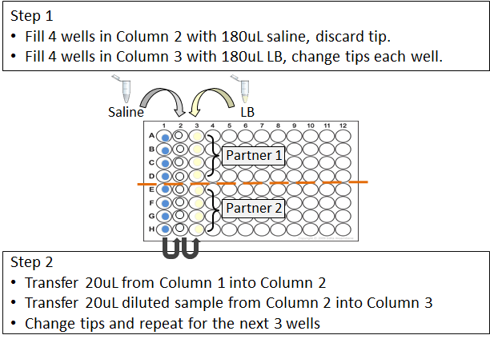

**Part II.** Start their experiment by taking a sample of fully grown culture and plate it onto Petri dishes with and without antibiotics. See image below.

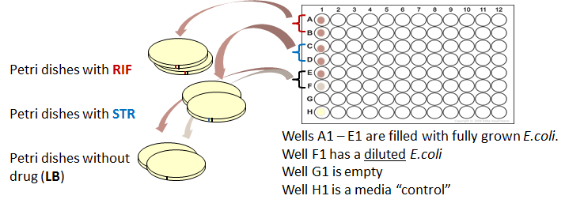

2 Weeks before the lab:

Calculate volumes needed and make media

* LB broth
* Saline
* LB agar
* Petri dishes with antibiotics

Note:

|  |
| --- |
| 1L flask of LB agar should fill around 50-60 Petri dishes |
| RIF Stock concentration is: 50mg/mL. Add 1 mL of stock per 1L of agar |
| STR Stock concentration is: 100mg/mL. Add 320uL of stock per 1L of agar  Below is an example if spreadsheet used to calculate media needs for the Petri dishes   |

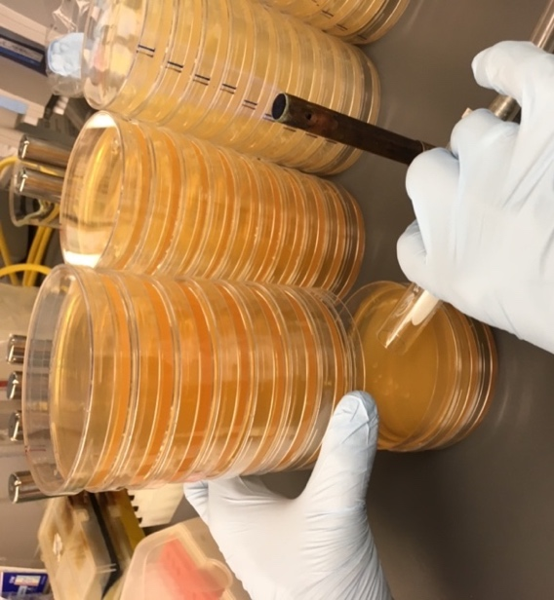

**Bead Petri dishes**

- Working by a flame or in a clean bench to maintain sterility

- Gently shake out 6 – 8 beads onto each Petri dish

- Once the Petri dishes are beaded, store them upside down so the beads are resting on the lid of the Petri dishes.

**Prep eppi tubes for sterile practice** (these do not need to be sterile)

[_] Label eppi tubes with a sharpie (black sharpie for media and blue for saline)

[_] Tubes will be filled with 1mL, either clear water or lightly colored yellow water, see below.

**Prep microtiter plates for sterile practice**,

[_] Label

[_] The first column of each MT plate will be filled with 200uL of blue water

**Once the eppi tubes and microtiter plates are prepped they can be stored until lab (for a week or more).

**2 days before TA meeting (and/or the 1st lab if there is no TA meeting):**

**PREP PART I:** Sterile technique practice

**MATERIALS (non-sterile):**

Each lab group will need:

2 eppi tubes labeled “LB” with light yellow water (to represent media)

2 eppi tubes labeled “saline” with water (to represent saline)

2 microtiter plate, first row filled with 180uL blue water (to represent bacteria)

Pipette tips

**Step-by-Step Prep**

Prep for Sterile practice

Materials needed:

* Reservoir for “bacteria”, blue** water (6 drops per 25-30mL of water)
* Beaker for “LB”, yellow** water (1 drop yellow per ~100mL of water)
* 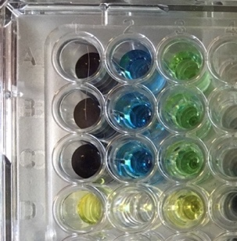Beaker for “saline”, water
* Eppis (these do not need to be sterile and can be reused next quarter/semester)

**coloring is optional but helpful for students and TA to make sure they are doing the steps correctly. The blue water is first diluted in “saline” so it becomes lighter blue and then the diluted “bacteria” is transferred in yellow “LB” turning greenish.

**STEPS:**

1) Label eppis (in black “LB” or in blue “Saline”)

2) Fill each with ~1.5mL of either clear water or colored water, light yellow (“LB”) (does *not* need to be exact volumes or sterile)

3) Label MT plates (optional)

4) Fill the first row (using a multi-channel) with 180uL of blue water

5) Eppis tubes and MT plates can be stored until use. Note: If you are storing the MT plates for several week (or more) bag them to prevent too much evaporation.

**PREP PART II.**

Experiment Prep: Start Experiment, plating bacteria on Petri dishes.

2 Days before TA meeting (or two days before the first lab section if no TA meeting)

To Do: Calculate how much bacteria you will need. Start the *E.coli* strain from the freezer (MG1655) into LB media to grow.

You may also want to calculate how much Common Competitor strain you will need to freeze down to use in Lab 5 (see “important note about Common Competitor” at the end of Day 1 prep steps)

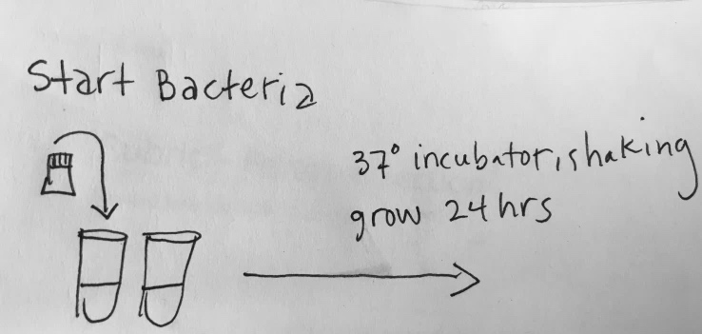

**MATERIALS:**

2 sterile test tubes (or flasks depending on volume)

Pipettes

Sterile pipette tips

-80 freezer access

Frozen *E.coli* strain

**STEPS:**

1. Label test tubes (one for the *E.coli* and the other as a media control)
2. Set your volume to the appropriate volume
3. Sterilize your work bench and your pipettes
4. Fill the test tube for the *E.coli* with ___mL of LB (the amount needed depends on your class size)
5. Fill the media control test tube with 2-5mL of LB (this amount doesn’t need to be exact, just enough to be able to tell if the media is clear or cloudy the next day).
6. Retrieve the bacteria from the freezer
7. Working swiftly and carefully, scrap across the frozen bacteria sample and swirl this pipette tip into the appropriate test tube containing LB
8. Return the bacteria to the freezer
9. Move both tubes to the shaking incubator set to 37 degrees C to grow over night.
10. Clean up
11. If you have time, prep for the next day

1 Days before TA meeting (or first lab section)

**To Do:** Calculate how many MT plates containing bacteria you will need.

Dilute and transfer bacteria making a “master plate”.

**Making a “master plate” is useful when prepping the materials for a **large scale** class (12 lab sections or more) but prep steps can be modified/simplified for a smaller class.

**MATERIALS:**

2 sterile test tubes

Pipettes

Sterile pipette tips

3 sterile reservoirs

___ Sterile Microtiter (MT) plates

___L of sterile Saline

___L of sterile LB media

Fully grown E.coli strain

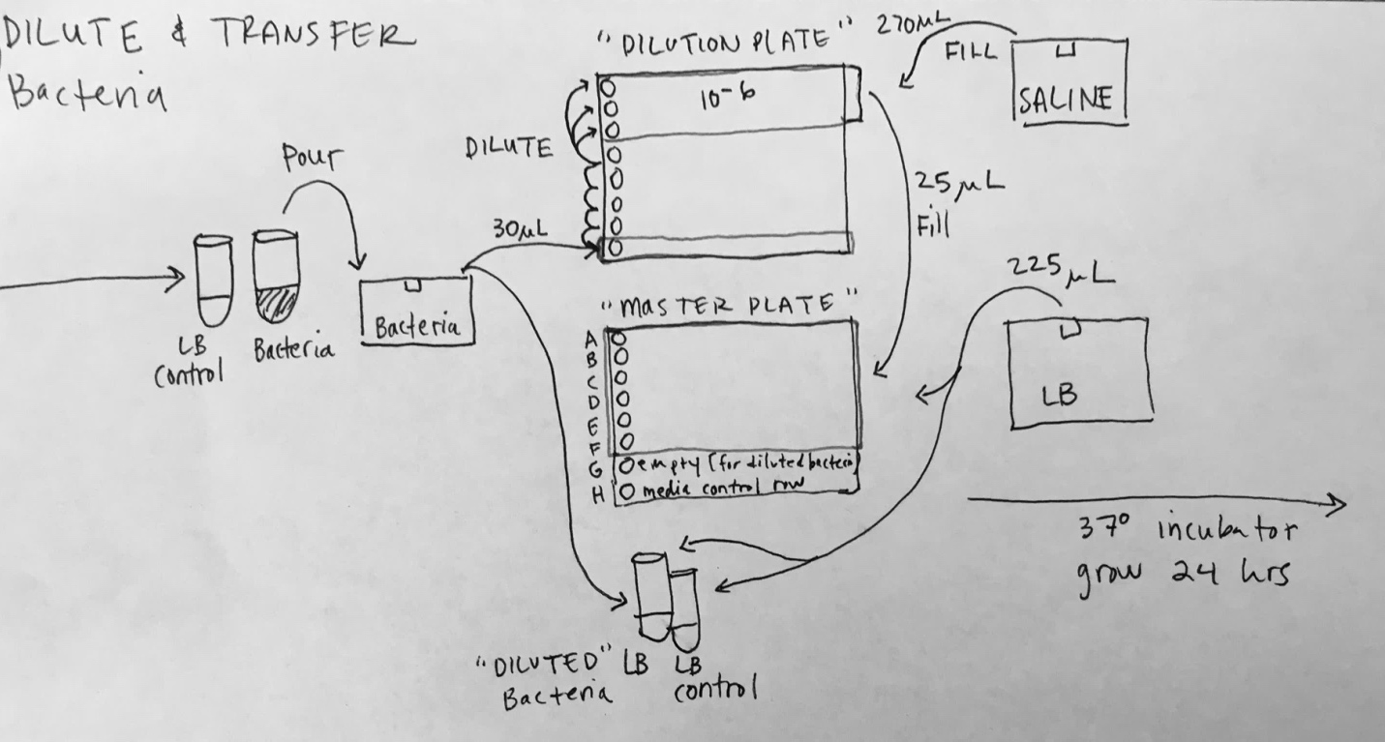

**STEPS:**

1. Label everything (1 reservoir for saline, 1 for *E.coli*, 1 for LB, 2 test tubes (one as a media control) “Dilution” MT plate(s), and “Master” MT plate(s)
2. Sterilize your work area and pipettes
3. Pipette or pour saline into the appropriate reservoir
4. Pipette or pour LB into the appropriate reservoir
5. Set your multichannel to 270uL, and fill the “dilution” MT plate with 270 saline
6. Change your multichannel to 225uL and fill the “Master” MT plate with 225uL except for row G
7. Retrieve your fully grown bacteria
8. Pour the bacteria into the appropriate reservoir
9. Set your multichannel to 30uL and fill the bottom row (H) of the “dilution” MT plate with 30uL of bacteria.
10. With new tips, dilute up (transferring 30uL each time and mixing) until you get to 10-6 (in row C.
11. From row D make multiple rows of 10-6, in rows A, B, and C.
12. Set your pipetted to 25uL
13. From the “dilution” MT plate, transfer 25uL of 10-6 bacteria into each well of the master plate except for row G and H (row G will stay empty to be filled tomorrow with diluted bacteria and row H will be the media control row).

*NOTE: each 10-6 well contains 300uL of bacteria, we are pipetting out 25uL multiple times (technically wells can be pipetted out of 12 times but due to small pipetting error over time, plan on 11 times).

1. Fill tests tubes with ___LB for the *E.coli* to grow over night (the 2nd test tube will be for the media control)
2. Transfer ___uL from the reservoir containing bacteria to the appropriate test tube
3. Place the test tubes and the “master” MT plate into the 37 C degree incubator to grow over night.
4. Clean up and if you have time prep for tomorrow

Days of TA meeting (or first lab sections)

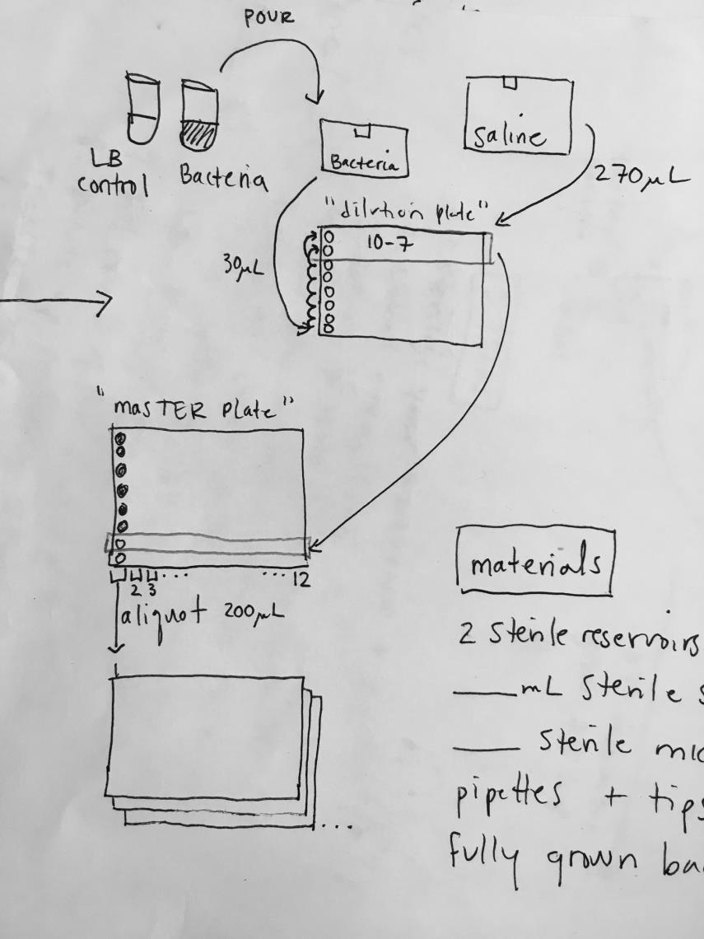

To Do: Dilute bacteria and add it to the “master” MT plate. Aliquot columns of bacteria from the “master” MT plate, 1 for each lab group.

**MATERIALS:**

Pipettes

Sterile pipette tips

2 sterile reservoirs

___ Sterile Microtiter (MT) plates

___L of sterile Saline

Fully grown E.coli strain

**STEPS:**

1. Label (bacteria reservoir, saline reservoir, “dilution” MT plate)
2. Sterilize your work area and pipettes
3. Pipette or pour saline into the appropriate reservoir
4. Set your multichannel to 270uL, and fill the “dilution” MT plate with 270 saline
5. Retrieve your bacteria from the incubator, check controls
6. Pour the bacteria into the appropriate reservoir
7. Set your multichannel to 30uL and fill the bottom row (H) of the “dilution” MT plate with 30uL of bacteria.
8. With new tips, dilute up (transferring 30uL each time and mixing) until you get to 10-7 (in row C.
9. From row C make multiple rows of 10-7, in rows A and B
10. Set your pipetted to 200uL
11. From the “dilution” MT plate, transfer 200uL of 10-7 bacteria into row G
12. Now you can aliquot each column of the “master” MT plate into new sterile MT plates, 1 for each lab group.
13. Set your pipette to 200uL and column 1 of the “master” MT plate will go into column 1 of the first groups MT plate, column 2 of the “master” MT plate will go into column 1 of the second lab groups MT plate, column 3 of the “master” MT plate will go into column 1 for group four etc….

*NOTE: Each “master” MT plate will make 12 groups.

1. If MT plates aren’t being used that day, store them in the refrigerator until the day of lab. There will be some evaporation, but this is ok. You can also bag the MT plates to help with evaporation.

**Lab room set up:**

The day of lab students will need…

For practice (items next to the green tray in the photo below):

* Microtiter plates to practice sterile technique
* Eppi tubes with water to practice sterile technique
* Non-sterile pipette tips

For starting their experiment (items in the green tray in the photo)

* Beaded Petri dishes (LB, LB + RIF, LB + STR)
* Microtiter plates containing bacteria
* Sterile pipette tips

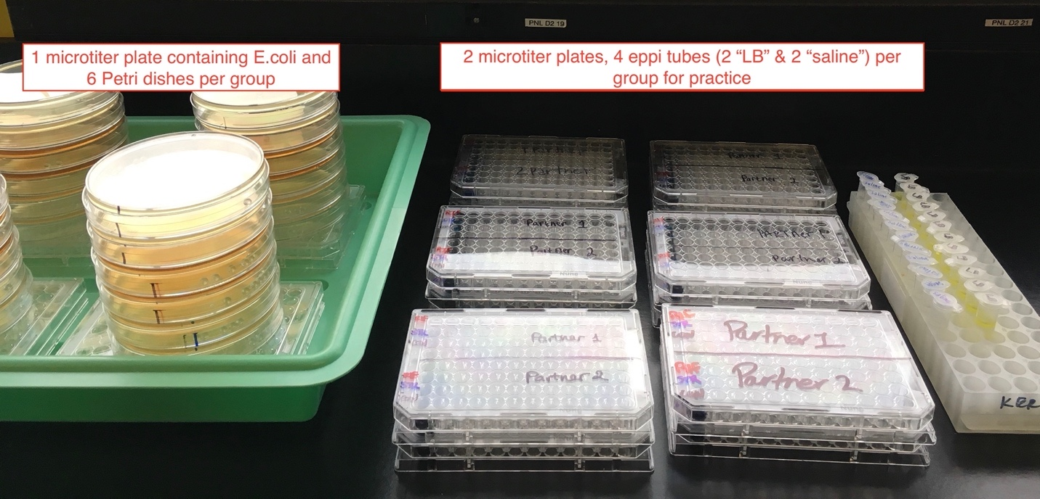

Note: It is important for students to understand what “biohazardous” is and requires sterile technique and proper PPE and what is for practices.

Because students are not working by a flame, to prevent contamination, we recommend that each lab students use freshly sterilize pipette tips for their experiment.

To minimize the workload, non-sterile tips (or “sterile” tip boxes that have been opened) can be used for their practice.

**Important Prep Note about the Common Competitor:**

In lab 5 the students will compete their focal strains (the progenitors and their descendants) against a common competitor strain.

If you have the lab help and your CURE is on the smaller scale, we recommend that Common Competitor goes through the same steps as the sensitive ancestor (dilute and plate in lab 1), in lab 2 select several colonies to grow overnight and freeze down the common competitor the same time all of the progenitors are frozen down.

However, you will need much more volume of your common competitor since it competes against every single strain.

Due to the nature of our large-scale CURE, we eliminated the plating step.

We grew our common competitor overnight is a microtiter plate and then froze down those wells at the same time that we froze the rest of the strains (the day after lab 2).

**STEPS**:

1. Label test tubes (one for the *Common Competitor* and the other as a media control)
2. Set your volume to the appropriate volume
3. Sterilize your work bench and your pipettes
4. Fill the test tube for the Common Competitor *E.coli* with ___mL of LB (the amount needed depends on your class size)
5. Fill the media control test tube with 2-5mL of LB (this amount doesn’t need to be exact, just enough to be able to tell if the media is clear or cloudy the next day).
6. Retrieve the bacteria from the freezer
7. Working swiftly and carefully, scrap across the frozen bacteria sample and swirl this pipette tip into the appropriate test tube containing LB
8. Return the bacteria to the freezer
9. Move both tubes to the shaking incubator set to 37 degrees C to grow over night.
10. Clean up

After 24 hours of growth

**STEPS:**

1. Label (bacteria reservoir, LB reservoir)
2. Sterilize your work area and pipettes
3. Pipette or pour LB into the appropriate reservoir
4. Set your multichannel to 180uL, and fill the MT plate with 180uL of LB
5. Retrieve your bacteria from the incubator, check controls
6. Pour the bacteria into the appropriate reservoir
7. Set your multichannel to 20uL and fill the MT plate with 20uL of bacteria (make as main well as you will need for the competition in lab 5).
8. Don’t forget to make a media control

# Lab 2

### Lab 2 Checklist:

**Make Media:**

Cornstarch mix

(tap) water for "saline" eppis

Light yellow-colored water for "LB" eppis

LB Broth for growing bacteria isolates (if not already made)

**Prep for student transfer practice:**

Fill wells A1, B1, F1 and G1 with 180ul cornstarch "bacteria" mix

Fill wells C1 and H1 with 180ul yellow-colored water

Fill Eppis with 1.5mL "LB" (yellow-colored water) and "saline" (water)

**Prep for students’ daily bacteria transfers:**

Label Eppi tubes

Fill sterile eppi tubes with LB (sterile)

Fill sterile eppi tubes with saline (sterile)

**Prep items for a dry load:**

Restock tips

Add autoclave tape to pipette tip boxes

Add eppis to autoclave safe containers, cover with foil, add autoclave tape

**Experiment Check:**

Check Petri dishes for growth

You want to make sure each lab section has some resistant colonies that students can select to continue their experiment. Ideally, each group should have colonies on some of their plates, but mutations are random.

* LB plates:
  + Should have a lawn/film of bacteria growth on the plates without diluted bacteria
  + LB plates that received the diluted bacteria should have single colonies
* LB + RIF plates:
  + most plates should have a few colonies on them. Some will have zero colonies.
* LB + STR plates:
  + we expect only 1/2 or a 1/3 of these plates will have colonies. They tend to be smaller colonies but will continue to grow outside of the incubator. It is a good idea to make extra Petri dishes with STR in case you need to plate more bacteria.

After incubation, move Petri dishes to a cold room for storage until lab 2.

### Prep Steps

**In this lab students will be doing two things:**

**Part I.** Continuing their experiment, each group will be selecting resistant isolates and transferring them into media, in a microtiter plate, to grow overnight. See figure below.

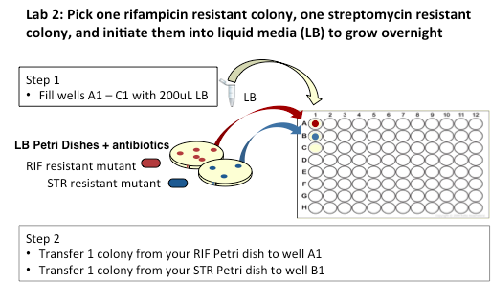

**Part II.** Practicing the daily transfer protocol they will start the day after lab and continue each day until week 5.

**PREP PART I.**

**Experiment prep: Select isolates and transfer into media**

**MATERIALS (sterile):**

Each lab group will need:

Their Petri dishes with colonies

1 sterile eppi tube filled with 1mL sterile LB

1 sterile microtiter plate

Pipette tips

**Step-by-Step Prep**

Materials needed:

* Sterile reservoir for LB
* Sterile eppi tubes labeled with a black “L” for LB (or use stickers if that is easier)
* Sterile pipette tips
* Pipette

**STEPS:**

1) Label eppis

**PREP PART II.**

**Practice how to do Daily Transfers**

**MATERIALS (non-sterile):**

Each lab group will need:

2 eppi tubes labeled “LB” with light yellow water (to represent media)

2 eppi tubes labeled “saline” with water (to represent saline)

2 microtiter plate, first row filled with 180uL cloudy water (to represent bacteria)

Pipette tips

**Step-by-Step Prep**

Prep for Daily Transfer practice

Materials needed:

* Reservoir for “bacteria”, cloudy water** (mix a little cornstarch or potato starch and water, roughly 1.0g cornstarch/100mL water)
* Beaker for “LB”, very light yellow** water
* Beaker for “saline”, water
* Eppis (these do not need to be sterile and can be reused next quarter/semester)

**optional but helpful for students and TA to make sure they are doing the steps correctly. The blue water is first diluted in “saline” so it becomes lighter blue and then the diluted “bacteria” is transferred in yellow “LB” turning greenish.

Note: If you have a small class and can do prep each week, feel free to rinse use the MT plates and Eppi tubes from last week. If you have a large class and have limited prep help, you may want to prep items before the quarter starts and store them until they are needed. Reusing them each quarter/semester.

**STEPS:**

1) Label eppis (in black “LB” or in blue “Saline”)

2) Fill each with ~1.5mL of either clear water or colored water, light yellow (“LB”) (does *not* need to be exact volumes or sterile)

3) Label MT plates (optional)

4) Fill the first row (using a multi-channel) with 180uL of cloudy water

5) Eppis tubes and MT plates can be stored until use. Note: If you are storing the MT plates for several week (or more) bag them to prevent too much evaporation.

**Lab room set up:**

The day of lab students will need…

For Daily Bacteria Transfer Practice

* Microtiter plates with cornstarch mixture to practice
* Eppi tubes with water (“LB” and “Saline”) to practice
* Non-sterile pipette tips

For their experiment

* Their Petri dishes from Lab 1 with resistant colonies
* Sterile eppi tubes with LB
* Sterile microtiter plates for selecting a colony to grow
* Sterile pipette tips

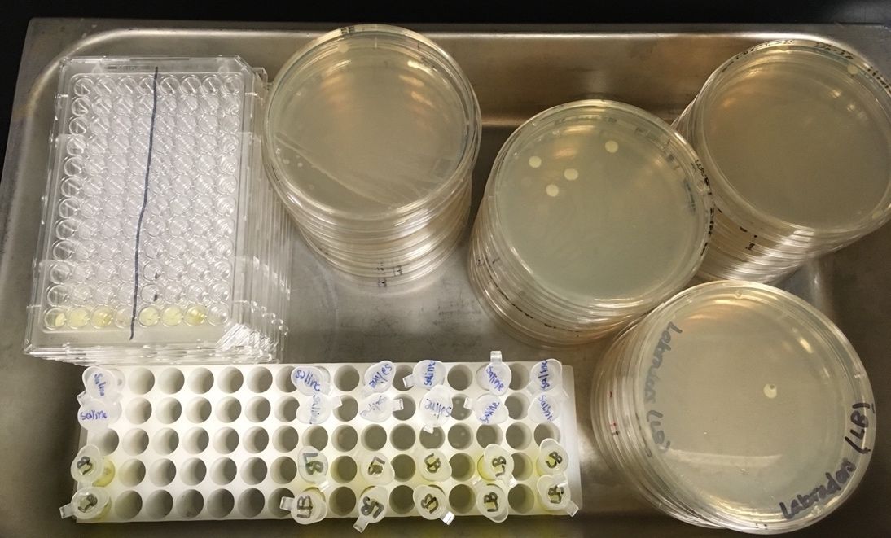

**After lab:**

Microtiter plates will need to be moved to the incubator by the instructor for the bacteria to grow.

Student will start their daily transfers tomorrow. After the first transfer is done, the instructor will freeze down the progenitors.

# Daily Transfers

Most of the prep for the daily transfers can be done ahead of time and the eppi tubes with sterile LB and Saline can be stored.

For the daily transfer, before the quarter started, we autoclaved all of the eppis we would need and closed them (to keep them sterile) in a BSC or laminar flow hood. We then labeled them for LB (in black) or Saline (in blue).

Filled them with the appropriate media and stored them in the fridge until use (see image below). Each student group used one LB eppi and 1 saline eppi tube per transfers.

If you are not running a large scale CURE you will have more freedom to adjust this prep as best suited for your labs and students.

Note:

* Stickers might be easier than labelling in Sharpie on the Eppi caps.
* Also be careful that your labelling scheme is different from the tubes that are used when students practice during Lab 1 and Lab 2 (those eppi tubes are NOT sterile and contain water to represent LB and Saline).

**Prep for students’ daily bacteria transfers:**

Make sure you have enough eppi tubes with sterile LB

Make sure you have enough eppi tubes with sterile saline

**Prep items for a dry load:**

Restock tips

Add autoclave tape to pipette tip boxes

If needed, autoclave tips

# Freezing down the progenitors

**Notes:**

A few tips before you freeze down the progenitors.

1. Check the student microtiter plates to make sure there is growth in the wells. You will want the students to have completed the first transfer so you can take the liquid remaining in the wells.

2. Ideally, we freeze bacteria with 80% glycerol to prevent cell death but if these strains are not going to stored long-term is less than ideal but ok to freeze them without glycerol. (Typically, we add 160uL of 80% glycerol to 1mL of fully grown bacteria, but we are freezing a very small volume of bacteria when we use microtiter plates).

3. Think about what will be easiest for you when you start the strains for the assays week 5. We froze our samples in MT plates but you need to make sure they are freezer safe and wont buckle in the freezer or when thawing.

This is what the MT plate will look like Lab 5: Freezing your bacteria in a similar pattern can help when you re-strain the progenitors.

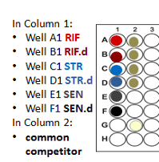

**Materials:**

Student microtiter plates

Instructor/TA microtiter plates with the sensitive strain

Common competitor strain

Sterile PCR tubes or microtiter plate for freezing the bacteria.

Sterile tips

Multichannel

**Steps:**

# Lab 3

### Lab 3 Checklist:

**Prep for students’ daily bacteria transfers:**

Make sure you have enough eppi tubes with sterile LB

Make sure you have enough eppi tubes with sterile saline

**Prep items for a dry load:**

Restock tips

Add autoclave tape to pipette tip boxes

If needed, autoclave tips

**If needed, run a waste load**

# Lab 4

### Lab 4 Checklist:

**Prep for students’ daily bacteria transfers:**

Make sure you have enough eppi tubes with sterile LB

Make sure you have enough eppi tubes with sterile saline

**Prep items for a dry load:**

Restock tips

Add autoclave tape to pipette tip boxes

**If needed, run a waste load**

# Lab 5

### Lab 5 Checklist:

**Make Media:**

X gal stock solution

IPTG stock solution

Rifampicin stock solution (if not already made)

Streptomycin stock solution (if not already made)

LB

**MIC assay prep**

Fill microtiter plates

* MT plates gradient of RIF
* MT plates gradient of STR

Eppis with saline

**Competition assay prep**

Petri Dishes with xgal & IPTG

Restart strains from the freezer

Start or restart the common competitor strain

Fill pppis with LB

**Prep items for a dry load:**

Reservoirs

Glass beads

Restock tips

Add autoclave tape to pipette tip boxes

Each lab group will need:

* 2 MIC plates,
  + one with a gradient of the antibiotic rifampicin and
  + the other with a gradient of the antibiotic streptomycin
* 12 eppi tubes will with 990uL sterile saline
* 2 full boxes of sterile pipette tips (plus extra)
* 12 Xgal & IPTG petri dishes, beaded
* 1 MIC plate containing their fully-grown bacteria (progenitors and descendants, common competitor) LB, and saline

### Prep Steps

This will be a big week for prep. Some of the work can be done ahead of time and items stored, such as: making the petri dishes with Xgal and IPTG and the MIC microtiter plates. However, preparing for the bacteria competitions will need to be done all week long. The preparations for this week need to be done carefully, data will be gathered and analyzed from the student’s assays.

For the competition assay, we prep the microtiter plates for the students due to lab time constraints. If your lab sessions are longer you can cut down on some of the prep and have the students do some of the work (such as adding LB to their competition MT plate or beads to their petri dishes) in lab.

**In this lab students will be doing two things:**

**Part I.** MIC assay

**Part II.** Competition assay

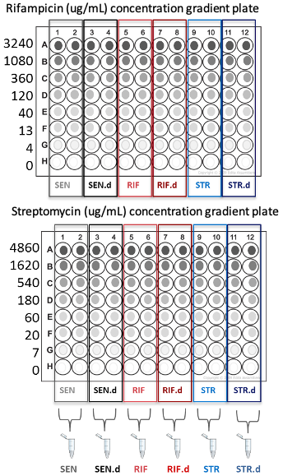**PREP PART I: MIC Assay.**

**MATERIALS:**

* Sterile reservoirs
* Pipette tips
* Microtiter plates
* Clean bench or BSC
* Bottles containing sterile LB, one bottle for each row of the MT plates (a total of 15 bottles)

**Notes:**

We developed this CURE to run in a large-scale introductory biology class. If you are running the CURE at a smaller scale you will want to adjust the prep steps appropriately.

For filling the MT plates with antibiotic, we suggest making a bottle of LB for each drug concentration and then pouring from that bottle into a reservoir, enabling you to use a multichannel pipette to fill each microtiter plate.

**Step-by-Step Prep**

1. Calculate how much LB you will need for each drug concentration (see *notes* below).

2. Make LB media (this will likely be 15 bottles of LB, the LB bottle with 0 antibiotic can be used to fill row H on both the RIF MT plates and the STR MT plates)

3. After autoclaving the media you will label which bottle is for which row of the MT plates. For example, the bottle for “STR row A” will get antibiotic stock so the concentration is 4860ug/mL. “STR row B” will have a concentration of 1620 ug/mL.

Note: It is easier to tell the bottles with different RIF concentrations apart since RIF is colored but the STR bottles will be impossible to tell apart if they are not labeled properly.

4. Label your reservoirs, one for each row of the MT plate for RIF and one for each row of the STR MT plates

5. Add the appropriate about of stock concentration to each bottle. Swirl to mix.

6. In a BSC or clean , Pour from the appropriate bottle into the appropriate reservoir.

7. Using a multichannel pipette, fill the appropriate row of each microtiter plate.

Note: If done carefully you will use one set of tips for each row (drug concentration)

**Notes:**

Example spreadsheet used to make the MIC drug gradient MT plates.

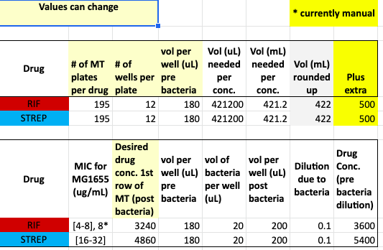

Remember, when you make the drug gradients you have to take into account the dilution that will occur when students add the bacteria to each well. For example we have each row (1-8) below and for each drug you will see the concentration before the bacteria is added and the drug concentration after the bacteria has been added…

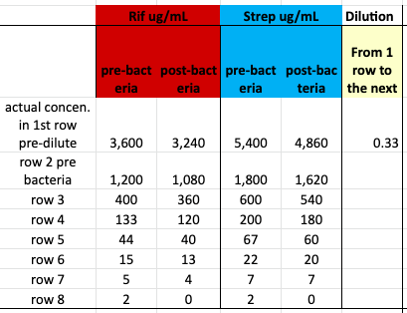

You will also need to calculate how much total volume of each drug concentration you will need to fill all of the microtiter plates.

In the step-by-step notes above, you can see that we add antibiotic to bottles containing a certain amount of LB. We then pour from these bottles into reservoirs and fill the microtiter plates using a multi-channel.

If you have a small number of MIC plates to make you can make one big batch of LB.

* Add the appropriate about of LB to each the reservoirs (one reservoir will have more LB than the others),
* Add the appropriate antibiotic amount for the *highest concentration* to one reservoir (the one with the extra LB)
* Dilute between reservoirs
* Then use a multichannel to fill

In this example spreadsheet, you can see the calculations for the two methods (adding antibiotic stock to bottles is on the left. Adding antibiotic stock to 1 reservoir and diluting down is on the right.).

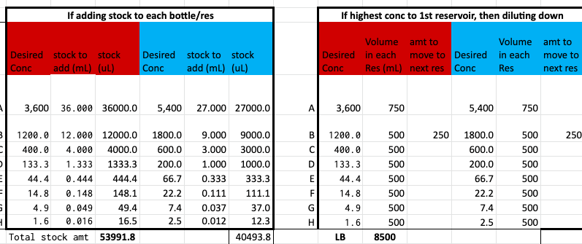

This image below is a schematic for how to perform a dilution in reservoirs.

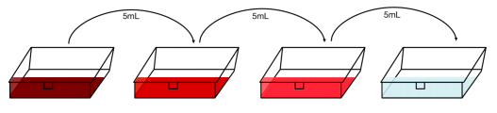

For both methods you need to know how much total LB you need and total amount of stock concentration (for each drug)

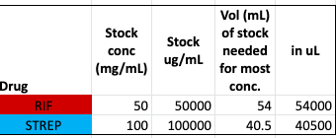

**PREP PART II: Competition Assay**

**MATERIALS:**

* Sterile reservoirs
* Pipette tips
* Microtiter plates
* Clean bench or BSC
* Bottles containing sterile LB
* Bottle of sterile saline

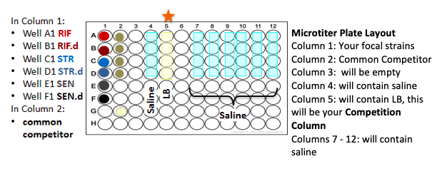

**Notes:**

We recommend you prep columns 4, 5, 7-12 ahead of time with LB and saline. Then store the microtiter plates, bagged up and in a cold location to prevent evaporation.

You can start the strains for each lab group in a separate microtiter plate and then the day of the lab aliquot the bacteria into the appropriate wells in column 1 and column 2.

**STEPS (for prepping the MT plate):**

1. Work by a flame or in a sterile clean bench
2. Label one reservoir for saline and a second reservoir for LB
3. Pour saline into the appropriate reservoir
4. Using a multichannel, fill wells A-D in columns 4, 7, 8,9,10,11, and 12 with 180uL sterile saline (column 12 is just extra)
5. Pour LB into the appropriate reservoir
6. Using a multichannel fill wells A5- D5 with 180uL of sterile LB media
7. Make a media control well (G2)
   1. Microtiter plates can be stored (bagged and in a cold room) until the day of lab if the prepared ahead of time.

**Complete final transfer and start the progenitor strains**.

You can either

1) Start/transfer strains into the MT plate, for each lab group, that will be used in Lab 5. But then you need to wait to prep the saline and LB wells (mentioned above) until the day of lab, after incubation, due to evaporation.

OR

2. You can start/transfer strains into a separate microtiter titer plate (several groups can fit on one plate) and then after incubator, transfer the fully grown bacteria into the MT that is pre-filled with LB and saline the day of lab.

Essentially the steps are the similar (you either add the saline and LB the day of lab or you transfer the fully grown bacteria from one MT plate to each groups MT plate that already contains LB and saline the day of lab).

**STEPS (for bacteria, following option 1 above)**

1. Work by a flame or in a sterile clean bench
2. Label one reservoir for LB
3. Using a multichannel pipette, add 195uL of LB to column 1, A-F and column 2, A - D.
4. Complete the final bacteria transfer for the students, but this time pipette 5uL into the appropriate wells in column 1, containing 195uL of LB.
5. To revive the progenitors, remove them (and the common competitors) from the -80 freezer. Leave them on the bench a minute to slightly thaw.
6. Add 5uL of each progenitor to the appropriate well in column 1.
7. Add 5uL of the common competitor to the appropriate well in column 2.
8. Move the MT plate to the incubator to grow overnight

**Additional notes:**

* **Freezing** the descendants and re-freezing the progenitors. At this stage, we can place the progenitors back in the freezer just in case of an emergency, however the student will be plating the progenitor and the descendants so if you want to make *long term freeze downs,* we recommend you go from a single colony from the petri dishes.

To make a long-term freeze down…

1. Using a sterile wire loop or sterile pipet tip, scrape up a single colony from petri dish

2. Inoculate a tube containing 5 ml of LB broth with the single colony

3. Incubate overnight, shaking in 37°C incubator

4. After incubation, pipet 160uL of 80% glycerol (per 1 ml of culture) into a labeled 1.5 ml Eppendorf tube or cryovial.

5. Add 1 ml of overnight culture (should be cloudy), mix carefully by pipetting up and down.

6. Immediately place in -80°C freezer (or on dry ice).

* Sensitive progenitor and descendant:
  + Each group of students will have 6 focal strains: the sensitive isolate and its descendant, the RIF-resistant strain and its descendant, and the STR-resistant strain and its descendant.
  + But because all of the experiments this quarter started with the same sensitive progenitor, the lab will just do one set of competitions with the sensitive progenitor and descendent (the strain that the instructor has been transferring daily for each lab section). This is an efficient way for each group to be able to compare their resistant strains’ fitness to the sensitive progenitor’s fitness.
  + However, you may opt to have each group plate their own SEN and SEN.d depending on your lab resources and time. (For the large scale CURE, we did this per lab sections which saved us ~1,100 Petri dishes).

Lab set up:

In the image below.

* Eppis on the left contain 990uL saline for the MIC assay, each group uses 12 eppis (diluting each strain twice so the group has two sets).
* The microtiter plate will contain the progenitor and their descendants (SEN, RIF, STR) in the first column.
  + Column 2 will get the Common Competitor strain
  + Column 4 has saline (to dilution the mixture for the competition)
  + Column 5 has LB (competition wells)
  + Columns 7-12 have saline for the dilution series
* The next stack of microtiter plates contains the drug gradients of rifampicin (on top, rifampicin is red) and streptomycin below (strep is clear).
* The last set of MT plates is for the t = 1 dilution series, after the competitions have had 24hrs to grow, they are filled with 180uL of saline. Students will also need a second set of LB Petri dishes for that drop-in day.

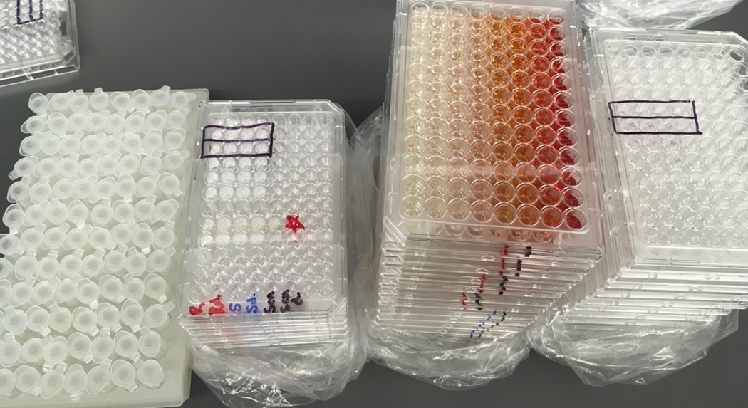

**Lab room set up:**

The day of lab students will need…

* Sterile pipette tips
* MT plate containing their strains and the common competitor
* Beaded LB Petri dishes
* Eppis containing saline
* MIC microtiter plates, with drug gradients

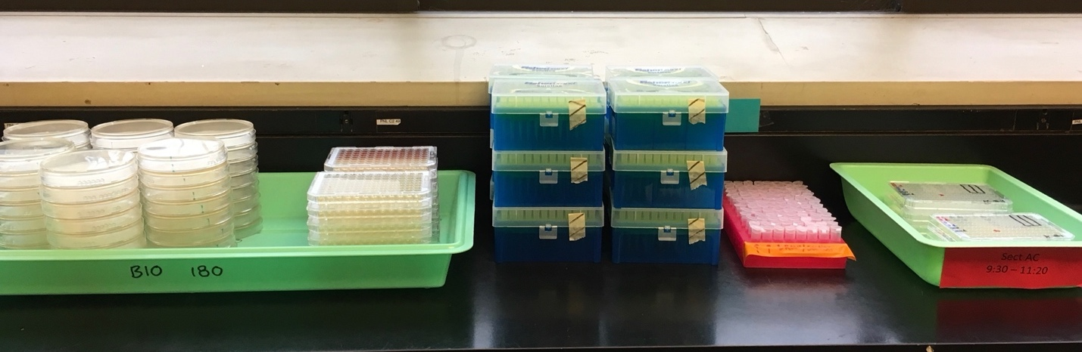

# T=1 Drop-In, competition plating

**Lab room set up:**

The day after lab 5 students will need…

* Sterile pipette tips
* MT plate containing their competitions
* Beaded LB Petri dishes (4 per group)
* Dilution microtiter plates, with 180uL saline

# Lab 6

Lab prep:

* Safety Googles
* Clickers
* Sharpies
* Bags to store Petri dishes (to use in lab 8)

Instructor (and/or students) will need:

* To enter results/data into the master spreadsheet

# Lab 7

No lab prep needed

Students will need:

* Laptops
* Results (in a csv file)
* Rcode

# Lab 8

### Lab 8 Checklist:

Program the Thermocycler

### Prep Steps

Program the thermocycler

|  |  |  |  |
| --- | --- | --- | --- |
| **Cluster I** |  |  |  |
| ***TaqDNA Polymerase Thermal Cycler conditions*** |  |  |  |
| **STEP** | **TEMP (C)** | **TIME** | **# OF CYCLES** |
| Initial Denature | 95 | 3 min | 1 |
| Denature | 95 | 30 sec | 25 |
| Anneal | 56 | 30 sec | 25 |
| Extend | 68 | 1 min 15 sec. (1 min/kb) | 25 |
| Final Extend | 68 | 5 min | 1 |
| Keep Cold | 4 (or 12) | Forever | 1 |
|  |  |  |  |
| Cluster II |  |  |  |
| ***TaqDNA Polymerase Thermal Cycler conditions*** |  |  |  |
| **STEP** | **TEMP (C)** | **TIME** | **# OF CYCLES** |
| Initial Denature | 95 | 3 min | 1 |
| Denature | 95 | 30 | 25 |
| Anneal | 54 | 30 sec | 25 |
| Extend | 68 | 1 min (1 min/kb) | 25 |
| Final Extend | 68 | 5 min | 1 |
| Keep Cold | 4 (or 12) | Forever | 1 |

**PCR prep**

*Objective*: Students will be amplifying two sections, “Cluster I” and “Cluster II” of the rpoB gene that is a known mutational “hotspot” associated with RIF-resistant phenotypes.

Reaction details:

|  |  |  |
| --- | --- | --- |
| **Primer set** | **Function** |  |
| Cluster I | Amplifies nt 1-1342 | Amino acids 140-148 |
| Cluster II | Amplifies nt 1240-2226 | Amino acids 508-574 |

<http://www.genetics.org/content/156/4/1471>

**(1)** **Setup**

Gather materials:

* Bucket of ice
* Rack for PCR tubes
* PCR tubes
* 2 centrifuge tubes for Master Mix stocks
* Multichannel pipette
* Pipette tips
* Chemicals:
  + Milli-Q water, in a tube in the fridge
  + dNTPs (-20 freezer)
  + Primers:
    - Cluster I forward “I fwd”
    - Cluster I reverse “I rev”
    - Cluster II forward “II fwd”
    - Cluster II reverse “II rev”
  + PCR buffer
* Pipette tip waste container for discarded tips
* Gloves
* Ethanol and kimwipes to clean your work space and pipettes
* Reservoirs in ice

Label the one centrifuge tube “MM I” on the cap and “Master Mix I” on the side plus the date. Label the second centrifuge tube “MM II” on the cap and “Master Mix II” on the side plus the date. That way you know which primer stock is in each one.

Each primer set will be made up in a separate stock mix, which then will be aliquoted into PCR tubes.

Spring 2019 we prepped for 220 reactions for each cluster (440 total). Made and aliquot Cluster II master mix first please (this mix is more critical to experiment success).

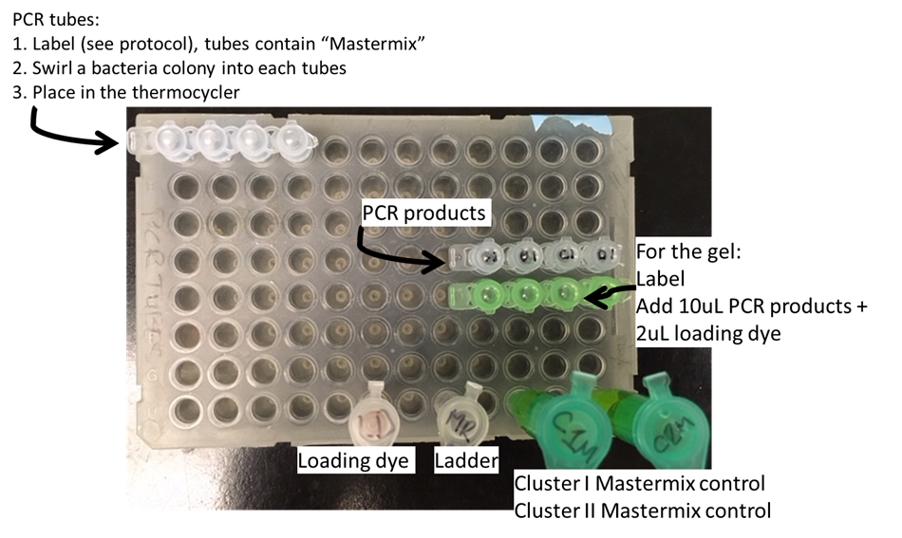

**(2)** **Put together reactions**

Put your PCR tubes and centrifuge tubes on ice. Remove all reagents from the -20°C freezer *except Taq polymerase.* In order to pipette, you will need the reagents to be thawed so you might need to *briefly* remove the reagents from the ice to thaw on the bench but make sure they go back on ice as soon as they liquefy and should be kept on ice afterward.

Use the recipe below to make up the stock mixes in the centrifuge tubes. Important note: The *DNA and *Taq polymerase will be added by students/TAs in lab.

MasterMix: PCR sample prep

On ice, thaw:

10 μM stock primers (Fwd & Rev) for Cluster I and Cluster II

dNTP’s

10X Taq buffer

Prepare the Master Mix (MM) by adding each component indicated in Table below. Because of the large # of sample you might make this in a centrifuge tube instead of an eppi

For example, here we are preparing for **220** reactions

|  |  |  |
| --- | --- | --- |
| ***Cluster I (uL)*** | |  |
| ***Taq PCR Calculation Template*** |  | # of rxns* |
|  | **µL Vol per 40 µL rxn** | **220** |
| **Water (Milli-Q)** | 30.7 | 6754 |
| **10x Taq buffer** | 4 | 880 |
| **dNTPS (10 mM stock)** | 0.8 | 176 |
|  |  |  |
| **10 µM F primer** | 2 | 440 |
| **10 µM R primer** | 2 | 440 |
| **Taq DNA polymerase (5U/ul)** | 0.5 | 110 |
| **TOTALS** | 3840 | Aliquot 40ul per tube |
| **Template DNA** | 0 | Add separately (this is each strain's different DNA) |
| **TOTALS** | **40** | **40 per tube** |
|  | total volume (uL) | 8800 |
| ***Cluster II (uL)*** | |  |
| ***Taq PCR Calculation Template*** |  | # of rxns* |
|  | **µL Vol per 40 µL rxn** | **220** |
| **Water (Milli-Q)** | 30.7 | 6754 |
| **10x Taq buffer** | 4 | 880 |
| **dNTPS (10 mM stock)** | 0.8 | 176 |
|  |  |  |
| **10 µM F primer** | 2 | 440 |
| **10 µM R primer** | 2 | 440 |
| **Taq DNA polymerase (5U/ul)** | 0.5 | 110 |
| **TOTALS** | 40 | Aliquot 40ul per tube |
| **Template DNA** | 0 | Add separately (this is each strain's different DNA) |
| **TOTALS** | **40** | **40 per tube** |
|  | total volume (uL) | 8800 |

*Note: Cluster II is where we are seeing most of the mutations, if funds (or time) are limited you can start by only sequencing Cluster II.

Vortex the Master Mix to mix. Note above I suggest making Cluster II MM first. Then aliquoting it into tubes and putting them into the freezer. This gives you a stopping point if you need to run to class. Then make Cluster I MM and add that to the frozen tubes containing MM II (see table below).

PCR tubes will be in strips of 8.

1. Fill up a PCR rack(s) with PCR tubes.
2. Put a single black line on the caps that will get MMI so you don’t get confused later on what is in which tube and a blue double line on the caps that will get MMII.
3. Spray a little 70% ethanol on your work bench and wipe it down with a kimwipe to create a sterile space for the tube caps.
4. Remove the caps.
5. Using a multichannel pipette at **40 uL** of MM into the appropriate tubes. To help with this, we will set up the tip box so if using the multichannel there will be two tips, a space, and then two more tips.
6. Once all the appropriate tubes are filled in one rack. Firmly close the tubes.
7. Double check the tubes are closed and flick or tap the strip on the lab bench to bring the liquid to the bottom of the tube and move the tubes to the -20 freezer.

Then work on the next batch.

Notes:

Checking volume as you go

If using the multichannel make sure volume is equal across all the pipette tips

Keeping everything on ice

You do not need to change tips with each strip of PCR tubes but change tips if they touch the bench or anything else

Work quickly but carefully

Double check the tube caps are on completely!!

Add 40 µL of stock mixture to the appropriate PCR tubes.

Cluster I MM goes into tubes 1, 2, 5 & 6. Cluster II MM into tubes 3, 4, 7, 8

|  |  |  |  |  |  |  |  |
| --- | --- | --- | --- | --- | --- | --- | --- |
| **1** | **2** | **3** | **4** | **5** | **6** | **7** | **8** |
| **I** | **I** | **II** | **II** | **I** | **I** | **II** | **II** |

Tubes strips will need to be cut in half. Each lab group needs 2 tubes (per the student protocol).

**Cleanup:**

If there is any unused MM store in the -20 freezer in HCK 218. Chemicals should be returned to the -20 freezer. Filled PCR tubes should also be stored in the -20 (this might change in the future)

**Students will do steps 1, 2, 3,5, and 6 below in lab**. The steps are here in case you need to redo any samples for the students due to an emergency.

1. Use a sterile pipette tip or toothpick to scrap across a RIF-progenitor colony* and swirl it into the appropriate PCR tube containing MasterMix

*Note: If colonies are small, they will have to use a separate RIF.P and RIF.D colony for each cluster this isn't ideal but is fine.

**Note: BLUE colonies are what we are taking, ignore the white which are the "common competitor"

1. Repeat for the RIF-descendant.
2. Put into the thermocycler.
3. While thermocycler is running, make gels and prep to do the next batch of PCR reactions.
4. Load sample and run gel
5. Visualize to see if there is a band (quick and dirty, is there product or not)

**Post Lab:**

Prepare samples to send away for sequencing.

1. Exo-sap enzyme clean up and

2. Send the strains away to Genewiz for sequencing.



Tips for processing a large number of samples:

|  |
| --- |
| - Make a "MasterMix" of water and primers (one for each cluster). |
| - Dot your DNA in on the side of the tube |
| - Add MasterMix, go to first stop only on the pipette and don't change pipette tip unless you touch the DNA |

# Lab 9

Set up computer:

* Benchling
* Sequencing Files

# Lab 10

Set up computer:

* Benchling
* Sequencing files
* Pymol
* Poster template

### Lab 11

Optional:

Computers to work on posters

# Lab 12

Set up for the poster session

* If students print posters you will need a way to hang the posters
* If students submit posters as a presentation to be projected, you will to set up projectors

Optional:

* Name tags
  + Sharpies
* Print poster session programs for guest
* Snacks
* Poster feedback forms

# Recipes

## **LB Broth**

**PURPOSE:**

A rich growth media for bacteria

**MATERIALS:**

* PPE
* Distilled or deionized water
* LB broth mix
* Bottle with cap
* Scale
* Scapula
* Weigh boat or paper
* Stir bar
* Magnetic stir plate
* Lab tape
* Autoclave tape
* Marker

|  |  |  |  |
| --- | --- | --- | --- |
| **INGREDIENT** | **500 mL bottle** | **1000 mL bottle** | **2000 mL bottle** |
| **Total volume of media** | **400 mL** | **800 mL** | **1800 mL** |
| LB Broth | 10 g | 20 g | 45 g |
| Distilled or Dionized water | 400 mL | 800 mL | 1800 mL |

**STEPS:**

1. Label bottles
2. Measure out the desired volume of powder and add to the bottle (extra space is provided in the bottle to prevent boil over in the autoclave however this may not be necessary for your autoclave so adjusted the broth/water ratio as needed).
3. Use a graduated cylinder to measure the dH2O. Add water to the appropriate volume
4. Carefully add a stir bar to bottle and mix ingredients. Once mixed, remove stir bar using magnetic stick.
5. **Loosely** screw on the caps (tightly sealing the caps before autoclaving can cause the bottles to explode)
6. Add autoclave tape
7. Autoclave on a liquid cycle for 30-45 minutes, depending on the size of the load.
8. Remove from the autoclave and tighten caps

## **LB Agar Plates**

**PURPOSE:**

LB agar Petri dishes are used for growing bacteria.

**MATERIALS:**

* PPE
* Distilled or deionized water
* LB Lennox Agar mix
* Flask
* Scale
* Scapula
* Weigh boat or paper
* Stir bar
* Magnetic stir plate
* Lab tape
* Autoclave tape
* Aluminum foil
* Marker

|  |  |  |
| --- | --- | --- |
| **INGREDIENT** | **1000 mL Flask** | **2000 mL flask** |
| **Total volume of media** | **500 mL** | **1000 mL** |
| LB Lennox Agar | 19 g | 38 g |
| Distilled water | 500 mL |  |

**STEPS:**

1. Label flaks
2. Measure out the desired volume of powder and add to the bottle (extra space is provided in the bottle to prevent boil over in the autoclave however this may not be necessary for your autoclave so adjusted the broth/water ratio as needed).
3. Use a graduated cylinder to measure the dH2O. Add water to the appropriate volume
4. Carefully add a stir bar to the flask and mix ingredients. Leave stir bar in while autoclaving.
5. Cover the flasks with foil
6. Add autoclave tape
7. Autoclave on a liquid cycle for 30-45 minutes, depending on the size of the load
8. After autoclaving, let the agar cool until ~65oC, it should be cool enough that you can comfortable touch the flask for 10 or more seconds. Once cool, immediately pour plates.

Note: Plates should be poured the same day the media is made although agar can temporarily be stored in the 55°C oven.

## **LB Petri dishes with Antibiotics**

**PURPOSE:**

We will be placing populations of bacteria on the Petri dishes to select for resistant cells. Making antibiotic plates using an LB Miller base and requires a antibiotic stock solution of the antibiotic you want to use.

**SAFTEY*:***

Almost all antibiotics are toxic to humans and should be handled carefully. Wear gloves and a lab coat, work in fume hood, and be careful not to inhale/ingest or have skin contact with antibiotics. Be sure to read more detailed information about each chemical and the chemical's MSDS*.*

1. Rifampicin, final plate concentration: 50 or 100 µg/ ml
2. Streptomycin, final plate concentration: 100 µg/ ml

Prepare Media & Autoclave according to the LB agar plate recipe.

**STEPS:**

**Add Antibiotics and Pour Plates**

1. Once finished autoclaving, set 2 L flask of media on a magnetic stirrer. Stir and allow to cool for about 15 minutes.
2. Use tape to make a label for each sleeve in which you will store your Petri dishes with the following information:

The kind of plates being poured, e.g. "LB + 50ug/mL RIF"

The date the medium was made

Your initials

1. Use the appropriately colored marker to assign the appropriate medium designation on the plates (i.e. LB plates have a single black line while Rif plates have a black and a red line.

**Antibiotic Plate Labeling**

|  |  |
| --- | --- |
| Rif | Strep |
| **||** | **||** |

1. Check to make sure that medium has cooled enough ~60oC to add the antibiotic stock. You should be able to place the back of your hand against the flask for a few seconds without it feeling too hot.
2. Bring your cooled medium to the bench and obtain antibiotic stock from the fridge or freezer.
3. Pipet the amount of antibiotic stock necessary to achieve the final plate concentrations above. *For example, if using 25 mg/ml Rifampicin stock, add 2 mL of stock to 1 L of medium to achieve a 50 µg/mL plate concentration.* Immediately return antibiotic stock to fridge/freezer when finished.
4. Place flask to magnetic stirrer for a few minutes to mix antibiotic, do not stir to vigorously or else this will cause bubbles in the agar
5. Bring flask back to bench and follow the Pouring Plates protocol.
6. Allow plates to cool for ~2-4 hours on the bench top before replacing in the sleeve and sealing with the tape-label. If you need to let the plates sit out longer, cover drying plates with a box or black garbage bag if plates contain light-sensitive antibiotics unless they are going to be used that day.
7. (Storage: Most antibiotic plates are light and heat sensitive. Store in a light-resistant container. Keep container tightly closed. Keep container in a cool (4°C), well-ventilated area.

Note: We aliquoted our antibiotic stock solutions, 1mL, into small tubes to store in the -20 C freezer.

## Streptomycin Solution

**100MG/ML STREPTOMYCIN SOLUTION**

**PURPOSE:**

In this CURE we are selecting for strains resistant to streptomycin and are evolving them to better understand the evolution of resistance, compensatory mutations, molecular basis of resistance and collateral (or cross-drug) effects.

**SAFTEY**:

Streptomycin is toxic and should be handled carefully. Personal protection (safety glasses, lab coat and gloves) should be worn and make sure to read the MSDS.

**NOTES:**

Streptomycin acts by inhibiting prokaryote protein synthesis by binding to the S12 protein of the 30S ribosomal subunit, thus preventing the transition from imitation complex to chain-elongating ribosome. This causes miscoding or inhibits initiation.  
Mode of Resistance: A mutation in rpsL a gene for S12 ribosomal protein, prevents binding of streptomycin to the ribosome. An aminoglycoside phosphotransferase also inactivates streptomycin.

Recipe adapted from Miller 1992: *A Short Course in Bacterial Genetics*

**Materials:**

* PPE (gloves, lab coat, goggles)
* Streptomycin powder
* Sterile bottle or Eppendorf tubes
* Filter
* Syringe
* Scale
* Scapula
* Weigh boat or paper
* Stir bar
* Magnetic stir plate
* Lab tape

|  |  |
| --- | --- |
| **INGREDIENT** | **20 mL bottle** |
| **Total volume of media** | **10 mL** |
| Streptomycin | 1 g |
| Distilled Water | 10 mL |

**STEPS:**

1. Put on proper PPE
2. Measure out the amount of powder you need and carefully pour it into a beaker.
3. Pipette in the appropriate amount of dH2O
4. Use the stir plate to mix, dissolving the streptomycin.
5. Filter sterilize solution into a sterile bottle (see the filter sterilization protocol for details)
6. STORAGE: Wrap in tinfoil and store at 4°C short term or aliquoted into sterile Eppendorf tubes and stored at -20°C for 1 year.

## Rifampicin Solution

**PURPOSE:**

In this CURE we are selecting for strains resistant to Rifampicin and are evolving them to better understand the evolution of resistance, compensatory mutations, molecular basis of resistance and collateral (or cross-drug) effects.

**SAFTEY*:***

Rifampicin (be sure to read an updated MSDS) is toxic and should be handled carefully. Personal protection (safety glasses, lab coat and gloves) should be worn when working with Rifampicin. All work with rifampicin should be done in the fume hood. **Always read a chemical's MSDS**. DMF is toxic and can dissolves some plastic materials, make sure you are storing stock solutions made with DMF in an appropriate container. DMF should be handled carefully.

Rif is soluble in dimethylformamide (DMF), dimethylsulfoxide (DMSO), methanol and chloroform. Be sure to follow all safety information for whichever solvent you use. Most of these solvents will prevent contaminates from growing so they do NOT need to be filter sterilized.

**NOTES:**

Rif inactivates bacterial RNA polymerase (RNAP). Rif has activity against a wide range of microorganisms. Bacterial resistance to Rif is due to mutations which result in changes in the structure of the ß subunit of RNA polymerase.

Recipe below adapted from Miller 1992: *A Short Course in Bacterial Genetics*

|  |  |
| --- | --- |
| **INGREDIENT** | **20 mL bottle** |
| **Total volume of media** | **10 mL** |
| Rifampicin | 500 mg |
| Dimethylformamide (DMF) | 10 mL |

**MATERIALS:**

* PPE
* Beaker for dissolving rifampicin (can be much larger than desired volume)
* Spatula
* Stir bar
* Waste bag and container for disposable rifampicin waste
* Parafilm for covering containers with rifampicin/ DMF
* 0.22 uM filter for sterilization*
* Syringe of desired volume for sterilization*
* 30-mL sterile bottle wrapped in foil or sterile Eppendorf tubes
* Rifampicin powder
* Fine-balance scale
* Stir plate
* Kim wipes
* Spray bottle of 70% ethanol
* Aluminum foil
* Extra gloves

**STEPS:**

1. Begin by placing the scale and stir plate in the fume hood.
2. Put on safety gear: lab coats, masks, goggles, gloves.
3. Weigh out rifampicin powder and carefully add to a beaker
4. Carefully pipette the appropriate volume of DMF into to the beaker with rifampicin and cover with parafilm.
5. Clean scale carefully
6. Use the stir plate to mix rifampicin and DMF. **Note: Make sure the stir bar doesn’t spin too fast and knock the beaker over.**
7. Once well mixed, turn the stir plate off.
8. If filter sterilizing, make sure the filters and storage containers are compatible with the solvent you are using (if different from DMF).
9. Use a pipette to transfer the stock solution into a sterile container for store (aliquot if needed).
10. STORAGE: Wrap in tinfoil or store in a light resistant container

* Label under foil and outside the foil with "Rifampicin in DMF, initials, date, concentration, flammable, toxic".
* Store at 4°C for short term or at -20 for longer term.

## **Saline**

**MATERIALS:**

* PPE
* Distilled or deionized water
* Sodium Chloride
* Bottle with cap
* Scale
* Scapula
* Weigh boat or paper
* Stir bar
* Magnetic stir plate
* Lab tape
* Autoclave tape
* Marker

|  |  |  |  |
| --- | --- | --- | --- |
| **INGREDIENT** | **500 mL bottle** | **1000 mL bottle** | **2000 mL bottle** |
| **Total volume of media** | **400 mL** | **800 mL** | **1800 mL** |
| Sodium Chloride | 3.4 g | 6.8 g | 17.2 g |
| Distilled water | 400 mL | 800 mL | 1800 mL |

**STEPS:**

1. Label bottles
2. Measure out the desired volume of sodium chloride and add to the bottle (extra space is provided in the bottle to prevent boil over in the autoclave however this may not be necessary for your autoclave so adjusted the broth/water ratio as needed).
3. Use a graduated cylinder to measure the dH2O. Add water to the appropriate volume
4. Carefully add a stir bar to bottle and mix ingredients. Once mixed, remove stir bar using magnetic stick.
5. Loosely screw on the caps (tightly sealing the caps before autoclaving can cause the bottles to explode)
6. Add autoclave tape
7. Autoclave on a liquid cycle for 30-45 minutes, depending on the size of the load.
8. Remove from the autoclave and tighten caps

## **Xgal/IPTG Agar Plates**

**PURPOSE**:

Petri dishes with X-Gal & IPTG agar are used in this lab to tell the focal strain apart from the common competitor (blue/white colonies)

**SAFETY*:***

*X-Gal and IPTG should be handled carefully. Wear gloves and a lab coat, work in fume hood, and be careful not to inhale/ingest or have skin****. Always read a chemical's MSDS****. DMF is toxic and can dissolves some plastic materials, make sure you are storing stock solutions made with DMF in an appropriate container.*

**NOTES***:*

β-galactosidase is naturally occurring *E. coli* protein and it is responsible for cleaving the sugar lactose into glucose and galactose. Cells that can produce β-galactosidase will also cleave a chemical called X-gal. X-gal is added to the LB in the indicator petri plates, when X-gal is cleaved by the cells on the Petri dish, one of the products is blue. IPTG (isopropylthio-β-galactoside) is an inducer of β-galactosidase activity in bacteria and is suitable for use with X-gal.

Our common competitor strain has a mutation in the gene for β-galactosidase that prevents the protein from being assembled properly. As a result, the competitor cells cannot cleave lactose. This is why colonies from the common competitor are white (their β-galactosidase cannot cleave X-gal and turn blue) while your focal strains are blue (their β-galactosidase can cleave X-gal and turn blue.

**STEPS:**

1. Make Stock solutions

* X-gal: 20 mg/ml solution. It must be dissolved in DMSO (dimethyl sulfoxide) or dimethyl formamide (DMF)
* IPTG**:** 0.1 M solution. The formula weight is 238.3, so this is 0.238 g in 10 ml of water

<https://www.nhm.ac.uk/content/dam/nhmwww/our-science/dpts-facilities-staff/Coreresearchlabs/iptg-and-xgal-for-blue-white-selection_aug12-118544.pdf>

2. Filter Sterilize

* See protocol on filter sterilization

3. Storage: Store stock solutions until use, double check storage information based on your needs.

* In general, it is recommended that X-gal is stored at -20°C in the dark.
* IPTG solution can be aliquoted and can be stored at room temperature short term or stored at −20 °C for up to a year.

4. Prepare Agar Media & Autoclave according to the LB agar plate recipe.

**Add Stocks and Pour Plates**

1. Once finished autoclaving, set 2 L flask of media on a magnetic stirrer. Stir and allow to cool for about ~15 minutes.
2. Use tape to make a label for each sleeve in which you will store your Petri dishes with the following information:

The kind of plates being poured, e.g. "LB + X-Gal/IPTG"

The date the medium was made

Your initials

1. Use the appropriately colored marker to assign the appropriate medium designation on the plates (i.e. LB plates have a single black line for X-Gal/IPTG plates you can use 3 black lines)
2. Check to make sure that medium has cooled enough ~60oC to add the stock solutions. You should be able to place the back of your hand against the flask for a few seconds without it feeling too hot.
3. Bring your cooled medium to the bench and obtain stock from the fridge or freezer.
4. Pipet the amount of stock necessary
   * X-gal, 2mL per 1L
   * IPTG, 1mL per 1L
5. Place flask to magnetic stirrer for a few minutes to mix, do not stir to vigorously or else this will cause bubbles in the agar
6. Bring flask back to bench and follow the Pouring Plates protocol.
7. Allow plates to cool for ~2-4 hours on the bench top before replacing in the sleeve and sealing with the tape-label. (Storage: These plates are light and heat sensitive. Store in a light-resistant container. Keep container tightly closed. Keep container in a cool (4°C), well-ventilated area.

## Filter Sterilization

**PURPOSE:**

To sterilize a media or stock solution that cannot be autoclaved to sterilize (usually because the solution is heat sensitive and will break down in the autoclave).

**SAFETY:**

Be sure to be aware of the safety concerns associated with the solution you are sterilizing in case of a spill.

**NOTE:**

It is recommended that you prewet a 0.22 µm syringe filter by drawing through 5-10 ml of sterile H2O and discard water.

**MATERIALS:**

* Sterile syringe
* 22 micron filter
* Sterile vial or tube
* Sterile dH2O
* Solution to be sterilized

**STEPS:**

1. Sterilize a BSC or a laminar flow hood.
2. Get the solution to be sterilized into the syringe you can either follow option a) or b)
   1. Attached the filter
      * Remove the plunger from the syringe and set aside.
      * Pour the solution into the syringe and replace the plunger.
   2. Suck all the mixture up into your syringe
      * then place the filter tip on the syringe
3. Open the sterile vial to and expel sterile solution into the vial (going through the 22 micron filter) by pushing down on the plunger.
4. Place the hypodermic needle in the sharps waste container and the syringe and filter in the biohazard waste.

## **OPTIONAL:**

**For Sterile practice**

* Blue water (“bacteria”)
* Regular water (saline)
* Light yellow water (LB broth)

Student dilute the bacteria in water (visually should be light blue)

Transfer the diluted “bacteria” into LB (should turn aqua-green).

BLUE WATER:

6 drops of blue food coloring per 25-30mL of water

Pour into a reservoir so you can use a multi-channel to fill microtiter plates

YELLOW WATER

1 drop yellow food coloring per ~100mL of water into a beaker to fill up eppi tubes

**For Transfer Protocol practice**

Instead of using blue water to represent bacteria we used a slightly cloudy mixture of water with corn starch or potato starch to make it look more realistic. Actual bacteria can always be used but then the MT plates are not reusable.

CORNSTARCH "bacteria"

1.0g cornstarch/100mL H2O recipe

# Glossary

Autoclave loads:

* “Dry” load: Autoclave load to sterilize items such as pipette tips, test tubes, bottles, Eppendorf tubes
* Media load: Autoclave load to sterilize media. Before the keep caps loose to allow for airflow in the autoclave but tighten the caps upon removal from the autoclave
* “Waste”

“Eppis”- eppendorf tubes (we used 1.5mL but it could be 2mL)

“MT”- Microtiter plate